<https://tilqural.kz/> 

<https://atau.kz/> 

<https://emle.kz/> 

<https://termincom.kz/> 

<http://balatili.kz/> 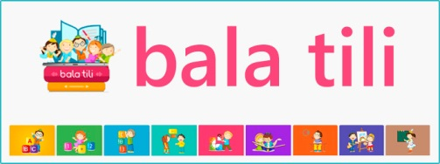

<https://www.qazlatyn.kz/> 

<https://sozdikqor.kz/> 

<https://tilalemi.kz/> 

<https://abai.institute/> 